YOLOv10-Based Real-Time Object Detection System
Submitted as a partial fulfillment of Bachelor of Technology in Computer Science & Engineering
Of
Adamas University



Mini Project Report
Submitted by

Name of Students | Roll No.
Aditya Sinha | UG/SOET/30/24/628
MD Roshike | UG/SOET/30/24/634
M A Sajad Ali | UG/04/BTCSE/2024/654
Jinihal Kumar Singh | UG/04/BTCSE/2024/649

Under the supervision of

Dr. Arnab Sinha
Associate Professor
Computer Science & Engineering Dept.

Department of Computer Science & Engineering,
Adamas University
P.O. - Jagannathpur, District - 24 Parganas (North),
Kolkata - 700 126

CERTIFICATE OF RECOMMENDATION

I hereby recommend that the project report prepared under my supervision by students listed below

Sl No | Name of the Student | Signature
1. | Aditya Sinha
2. | MD Roshike
3. | M A Sajad Ali
4. | Jinihal Kumar Singh

for the project entitled “YOLOv10-Based Real-Time Object Detection System” be accepted in fulfillment of the requirements for the degree of Bachelor of Technology in Computer Science & Engineering.

--------------------------------------
Project Guide
Dr. Arnab Sinha
Associate Professor
Computer Science & Engineering Dept.

CERTIFICATE

This is to certify that the project entitled “YOLOv10-Based Real-Time Object Detection System” is submitted by

Sl No | Name of the Student | Registration Number
1. | Aditya Sinha | AU/2024/0003184
2. | MD Roshike | AU/2024/0003277
3. | M A Sajad Ali | AU/2025/0003741
4. | Jinihal Kumar Singh | AU/2025/0003062

has been carried out under the guidance of myself following the rules and regulations of the degree of Bachelor of Technology in Computer Science & Engineering, Adamas University, Kolkata.

(Signature of the students)

________________________________
________________________________
________________________________
________________________________
________________________________



Adamas University

CERTIFICATE OF APPROVAL

This project report is hereby approved as a creditable study of an engineering subject carried out and presented in a manner satisfactory to warrant its acceptance as a prerequisite to the degree for which it has been submitted. It is to be understood that by this approval, the undersigned does not necessarily endorse or approve any statement made, opinion expressed, and conclusion drawn therein but approve the project report only for the purpose for which it has been submitted

FINAL EVALUATION OF PROJECT REPORT

Acknowledgment

We would like to express our sincere gratitude to our Project Co-ordinator for their continuous support, guidance, and encouragement throughout the completion of this mini project. Their timely feedback and suggestions were extremely helpful in keeping our work on the right track.

We are also thankful to Adamas University and the Department of Computer Science and Engineering for providing us with the necessary infrastructure, laboratory facilities, and academic resources that made the execution of this project possible.

We would also like to acknowledge the open-source community whose tools and libraries formed the backbone of this project. Special thanks to the Ultralytics team for making YOLOv10 publicly available, the OpenCV community for their powerful computer vision library, and the developers behind Python, Pillow, and Tkinter without these freely available resources, this project would not have been achievable.
Table of Contents

Sl No | Topic | Page No
1 | Introduction | 1-2
2 | Related Work | 3-4
3 | Methodology | 5-6
4 | Result Analysis | 7
5 | Discussion | 8
6 | Conclusion | 9
7 | Future Work | 10
8 | References | 11
9 | Appendices | 12-13

Introduction

1.1 Background
Object detection is one of the fundamental tasks in computer vision, involving the identification and localization of objects within digital images or video streams. Over the past decade, deep learning-based approaches particularly those built on Convolutional Neural Networks (CNNs) have revolutionized the accuracy and speed of object detection systems. Among the various architectures developed, the YOLO (You Only Look Once) family of models stands out for its exceptional balance of speed and accuracy, making it particularly suitable for real-time applications.
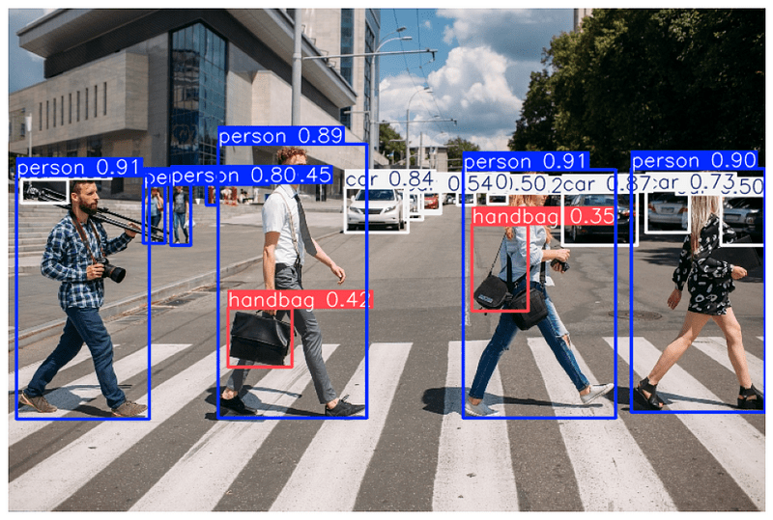

1.2 Problem Statement
Despite the existence of powerful object detection models, most research implementations lack an accessible, interactive user interface that non-experts can use without deep technical knowledge. Deploying real-time detection systems typically requires expertise in command-line tools, scripting, and hardware configuration. This gap between research-grade models and usable applications creates a barrier for practical adoption in fields such as surveillance, robotics, retail analytics, and educational demonstrations.

1.3 Objectives
The primary objectives of this project are:
- To implement YOLOv10, the latest generation of the YOLO architecture, for real-time object detection from a live webcam feed.
- To develop an intuitive Graphical User Interface (GUI) using Python's Tkinter library that allows users to control detection parameters without any coding knowledge.
- To provide real-time performance metrics including Frames Per Second (FPS), object count, unique class count, and average confidence score.
- To support all six YOLOv10 model variants (N, S, M, B, L, X) enabling users to trade off speed versus accuracy based on their hardware.
- To demonstrate the practical applicability of state-of-the-art deep learning models in a deployable desktop application.

1.4 Scope
This project focuses on real-time video-based detection using a standard webcam as the input source. The system is designed for CPU-based inference, making it accessible on consumer-grade laptops and desktop computers without requiring a dedicated GPU. The application is built for Windows, Linux, and macOS environments supporting Python 3.10 and above.

Related Work

2.1 Evolution of YOLO
The YOLO architecture was first introduced by Redmon et al. (2016) as a single-stage detector that reframed object detection as a regression problem, predicting bounding boxes and class probabilities directly from full images in a single evaluation. This made it significantly faster than two-stage detectors like Faster R-CNN, which require a separate region proposal step.
Subsequent iterations — YOLOv2 (2017), YOLOv3 (2018), YOLOv4 (2020), and YOLOv5 (2020) — progressively improved accuracy through better backbone networks, feature pyramid networks, and data augmentation strategies. YOLOv8, released by Ultralytics in 2023, introduced a more modular architecture with improved anchor-free detection and a streamlined training API.

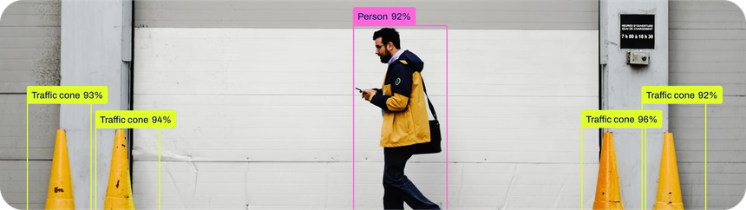

2.2 YOLOv10
YOLOv10 was introduced in 2024 by researchers from Tsinghua University. Its primary innovation is the elimination of Non-Maximum Suppression (NMS) post-processing through a dual-label assignment strategy during training. One-to-many label assignment improves training supervision richness, while one-to-one assignment enables direct, NMS-free inference. This architectural change reduces end-to-end latency while maintaining competitive accuracy on the COCO benchmark.

2.3 GUI-Based Detection Systems
Several prior works have explored building interfaces for object detection systems. Tkinter-based interfaces have been used in academic projects for face recognition and traffic monitoring. However, most existing systems are either tied to older architectures or lack real-time performance feedback. This project bridges that gap by integrating the latest YOLOv10 model with a modern, responsive GUI.

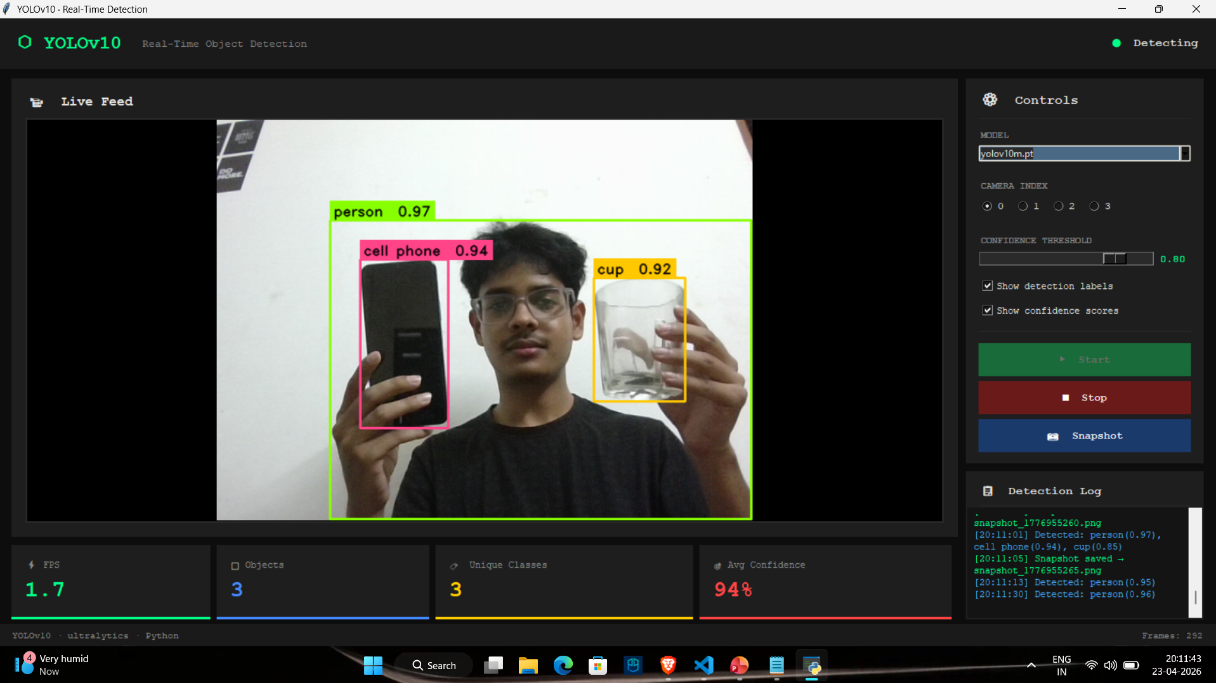

Methodology

3.1 System Architecture
The system is designed as a multi-threaded desktop application. A background daemon thread handles all computationally intensive operations — camera frame capture and YOLOv10 inference — while the main thread is reserved exclusively for Tkinter GUI updates. Communication between threads is achieved using Python's root.after() mechanism, which safely schedules GUI updates from the detection thread to execute on the main thread, preventing race conditions and UI freezes.

3.2 Detection Pipeline
The detection pipeline consists of five sequential stages:
- Camera Capture: OpenCV's VideoCapture class opens the webcam and reads frames in BGR format at the device's native resolution.
- Preprocessing: Each frame is passed directly to the YOLOv10 model, which internally resizes and normalizes it to 640×640 pixels.
- Inference: The YOLO.predict() method from the Ultralytics library runs forward inference, returning bounding box coordinates, confidence scores, and class IDs.
- Post-processing: Since YOLOv10 is NMS-free, detected boxes are used directly. Custom drawing code renders colored bounding boxes and labels on the frame using OpenCV.
- GUI Update: The annotated frame is converted to a Pillow Image and then a Tkinter PhotoImage, which is rendered on the Canvas widget.

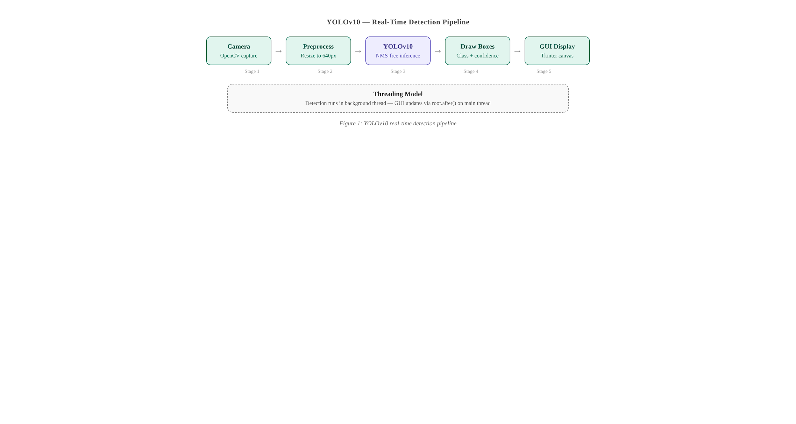

3.3 Model Selection
Six YOLOv10 model variants are made available to the user at runtime: N (nano), S (small), M (medium), B (balanced), L (large), and X (extra-large). All models are pre-trained on the COCO dataset, which includes 80 object classes including persons, vehicles, animals, and everyday objects. The models are automatically downloaded from the Ultralytics model hub on first use via the ultralytics Python package.

3.4 GUI Design
The GUI is built using Python's built-in Tkinter library with a dark-themed color palette (deep navy background with cyan accents) to reduce eye strain during extended use. Key GUI components include: a live canvas for video display, a control panel with model selector, camera index radio buttons, confidence threshold slider, detection label and confidence score toggles, Start/Stop/Snapshot buttons, four real-time stat cards, and a scrollable color-coded detection log.

3.5 Tools and Technologies

The project was developed using the following technologies:
Technology | Version | Purpose
Python | 3.10+ | Core programming language
Ultralytics | 8.3+ | YOLOv10 model implementation & inference API
OpenCV | 4.9+ | Camera capture and image processing
Pillow (PIL) | 10.0+ | Frame conversion for Tkinter display
Tkinter | Built-in | GUI framework — Canvas, widgets, event loop
Threading | Built-in | Daemon thread for non-blocking detection

Result Analysis

4.1 Model Performance on COCO Benchmark
Table 4.1 presents the performance benchmarks of all six YOLOv10 model variants on the COCO val2017 dataset. Latency is measured on T4 GPU with TensorRT FP16. CPU latency figures for YOLOv10-N are approximately 30 FPS on a standard Intel Core i5 processor, making it suitable for the real-time GUI application.

Model | Params (M) | mAP50-95 | Latency (ms) | Recommended For
YOLOv10-N | 2.3 | 38.5 | 1.84 | Edge devices / Mobile
YOLOv10-S | 7.2 | 46.3 | 2.49 | Real-time applications
YOLOv10-M | 15.4 | 51.1 | 4.74 | Balanced accuracy-speed
YOLOv10-B | 19.1 | 52.5 | 5.74 | High accuracy needs
YOLOv10-L | 24.4 | 53.2 | 7.28 | Server / GPU systems
YOLOv10-X | 29.5 | 54.4 | 10.70 | Maximum accuracy

Table 4.1: YOLOv10 Model Comparison on COCO val2017

4.2 GUI Runtime Performance
During testing on a laptop with Intel Core i5-12th Gen CPU and 16GB RAM, the YOLOv10-N model achieved approximately 28–32 FPS through the GUI pipeline including camera capture, inference, annotation drawing, and Tkinter canvas rendering. The detection log correctly timestamped all detections, and the confidence slider dynamically adjusted filtering without requiring a model restart.

4.3 Detection Accuracy Observations
The system correctly identified common objects from the COCO dataset including persons, chairs, laptops, mobile phones, and bottles under standard indoor lighting conditions. Detection accuracy degraded slightly under low-light conditions and with heavily occluded objects, which is consistent with the expected behavior of models trained on the COCO dataset.

Discussion

5.1 Interpretation of Results
The results confirm that YOLOv10's NMS-free architecture offers a measurable reduction in end-to-end inference latency compared to its predecessors while maintaining competitive mAP scores. The elimination of NMS post-processing is particularly beneficial for the GUI pipeline, where every millisecond saved in post-processing directly contributes to higher FPS in the live display.

5.2 Challenges Faced
- Thread Safety: Tkinter is not thread-safe. Calling any GUI update from the detection thread caused intermittent crashes. This was resolved by using root.after() to schedule all GUI operations on the main thread.
- Memory Management: Holding references to PhotoImage objects in Python is mandatory. Without an explicit reference, Tkinter's garbage collector destroys the image before it is rendered, causing the canvas to go blank. This was handled by storing the current frame's PhotoImage in an instance variable.
- Model Download Latency: YOLOv10 weights are downloaded automatically on first use, which can take 10–30 seconds depending on internet speed. A loading indicator in the GUI status label addresses this UX concern.
- Camera Index Variability: On systems with multiple cameras, the correct device index varies. Radio button camera index selection was added to the GUI to allow users to switch between camera 0–3 without restarting the application.

5.3 Potential Improvements
Future iterations of the system could benefit from GPU acceleration through CUDA or TensorRT, which would increase FPS by 5–10x. Additionally, adding a video file input option alongside webcam input would expand the application's utility beyond live detection.

Conclusion

This project successfully demonstrates the integration of YOLOv10, a state-of-the-art NMS-free object detection architecture, into a fully functional, real-time desktop application with an intuitive graphical user interface. The system achieves live detection at approximately 30 FPS on standard consumer CPU hardware using the YOLOv10-N model, making it practically usable without any specialized hardware.
The GUI provides a comprehensive set of controls including model size selection, camera index switching, confidence threshold adjustment, label visibility toggles, real-time performance metrics, a color-coded detection log, and snapshot functionality. The multi-threaded architecture ensures UI responsiveness at all times, while the thread-safe root.after() design pattern prevents race conditions inherent in Tkinter applications.
The project demonstrates that modern deep learning research can be made accessible to end users through thoughtful software engineering, and that the barrier between research-grade models and usable applications can be significantly reduced with appropriate tooling.

Future Work / Recommendations

The following enhancements are recommended for future iterations of this project:
- GPU Acceleration: Integrate CUDA and TensorRT support for 5–10x FPS improvement on NVIDIA GPUs.
- Custom Model Training: Allow users to fine-tune YOLOv10 on domain-specific datasets (e.g., medical imaging, industrial defect detection) directly through the GUI.
- Video File Input: Extend the detection pipeline to support video files (.mp4, .avi) in addition to live webcam feeds.
- Class-Specific Alerts: Implement an alert/notification system that triggers when specific object classes (e.g., persons in restricted zones) are detected.
- Export Functionality: Add the ability to export detection results as CSV logs or annotated video files.
- ONNX / CoreML Export: Enable model export to ONNX for cross-platform deployment and CoreML for Apple Silicon devices.
- Web Interface: Develop a Flask or FastAPI-based web interface to allow browser-based access to the detection system.

References

1. Wang, Ao, Hui Chen, Lihao Liu, Kai Chen, Zijia Lin, Jungong Han, and Guiguang Ding. "YOLOv10: Real-Time End-to-End Object Detection." arXiv preprint arXiv:2405.14458 (2024).
2. Redmon, Joseph, Santosh Divvala, Ross Girshick, and Ali Farhadi. "You Only Look Once: Unified, Real-Time Object Detection." In Proceedings of the IEEE Conference on Computer Vision and Pattern Recognition, 779–788. 2016.
3. Jocher, Glenn, Ayush Chaurasia, and Jing Qiu. "Ultralytics YOLOv8." GitHub, 2023. https://github.com/ultralytics/ultralytics.
4. Lin, Tsung-Yi, Michael Maire, Serge Belongie, James Hays, Pietro Perona, Deva Ramanan, Piotr Dollár, and C. Lawrence Zitnick. "Microsoft COCO: Common Objects in Context." In European Conference on Computer Vision, 740–755. Springer, Cham, 2014.
5. OpenCV Contributors. "OpenCV: Open Source Computer Vision Library." GitHub, 2024. https://github.com/opencv/opencv.

Appendices

Appendix A: Installation Instructions
Prerequisites: Python 3.10 or above must be installed on the system.
Step 1 — Install required libraries:
pip install ultralytics opencv-python pillow
Step 2 — Run the application:
python yolov10_detection_gui.py
Step 3 — On first launch, select the desired model (YOLOv10-N recommended for CPU), choose the camera index (typically 0), set confidence threshold, and click Start Detection. The model weights will be downloaded automatically.

Appendix B: Key Source Code Snippets
The following snippet shows the core YOLOv10 inference call within the detection loop:

# YOLOv10 inference using Ultralytics API
results = self.model.predict(
source=frame,
conf=conf_thresh,
verbose=False,
imgsz=640,
)
result = results[0]
boxes = result.boxes
class_ids = boxes.cls.tolist()
confs = boxes.conf.tolist()

Appendix C: Sample Output

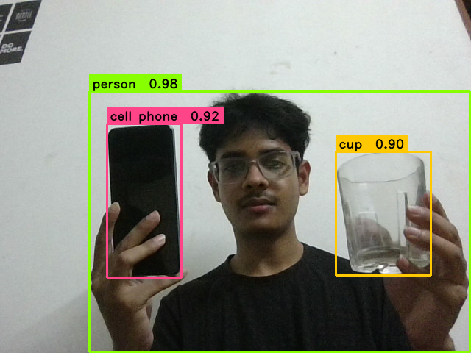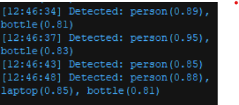
Snapshot saved
Detection logs with entries

Appendix D: System Requirements
Component | Minimum Requirement
Operating System | Windows 10 / Ubuntu 20.04 / macOS 11
Python Version | 3.10 or above
RAM | 8 GB (16 GB recommended)
CPU | Intel Core i5 / AMD Ryzen 5 or above
GPU (Optional) | NVIDIA CUDA-capable GPU for acceleration
Camera | Standard USB webcam or built-in laptop camera
Storage | 1 GB free space for model weights

